Name :-Mahajan Manisha Ajay
Roll No:- 61
Practical no:- 2
Practical Name:- Implemente the candidate elimination inductive learning algorithm.

import csv

with open("/ml2.csv") as f:
csv_file=csv.reader(f)
data=list(csv_file)

s=data[1][:-1]
g=[['?' for i in range(len(s))] for j in range(len(s))]

for i in data:
if i[-1]=="Yes":
for j in range(len(s)):
if i[j]!=s[j]:
s[j]='?'
g[j][j]='?'

elif i[-1]=="No":
for j in range(len(s)):
if i[j]!=s[j]:
g[j][j]=s[j]
else:
g[j][j]="?"
print("\nSteps of Candidate Elimination Algorithm",data.index(i)+1)
print(s)
print(g)
gh=[]
for i in g:
for j in i:
if j!='?':
gh.append(i)
break
print("\nFinal specific hypothesis:\n",s)

print("\nFinal general hypothesis:\n",gh)

Output:-
Steps of Candidate Elimination Algorithm 1
['Sunny', 'Warm', 'Normal', 'Strong', 'Warm', 'Same']
[['?', '?', '?', '?', '?', '?'], ['?', '?', '?', '?', '?', '?'], ['?', '?', '?', '?', '?', '?'], ['?', '?', '?', '?', '?', '?'], ['?', '?', '?', '?', '?', '?'], ['?', '?', '?', '?', '?', '?']]

Steps of Candidate Elimination Algorithm 2
['Sunny', 'Warm', 'Normal', 'Strong', 'Warm', 'Same']
[['?', '?', '?', '?', '?', '?'], ['?', '?', '?', '?', '?', '?'], ['?', '?', '?', '?', '?', '?'], ['?', '?', '?', '?', '?', '?'], ['?', '?', '?', '?', '?', '?'], ['?', '?', '?', '?', '?', '?']]

Steps of Candidate Elimination Algorithm 3
['Sunny', 'Warm', '?', 'Strong', 'Warm', 'Same']
[['?', '?', '?', '?', '?', '?'], ['?', '?', '?', '?', '?', '?'], ['?', '?', '?', '?', '?', '?'], ['?', '?', '?', '?', '?', '?'], ['?', '?', '?', '?', '?', '?'], ['?', '?', '?', '?', '?', '?']]

Steps of Candidate Elimination Algorithm 4
['Sunny', 'Warm', '?', 'Strong', 'Warm', 'Same']
[['Sunny', '?', '?', '?', '?', '?'], ['?', 'Warm', '?', '?', '?', '?'], ['?', '?', '?', '?', '?', '?'], ['?', '?', '?', '?', '?', '?'], ['?', '?', '?', '?', '?', '?'], ['?', '?', '?', '?', '?', 'Same']]

Steps of Candidate Elimination Algorithm 5
['Sunny', 'Warm', '?', 'Strong', '?', '?']
[['Sunny', '?', '?', '?', '?', '?'], ['?', 'Warm', '?', '?', '?', '?'], ['?', '?', '?', '?', '?', '?'], ['?', '?', '?', '?', '?', '?'], ['?', '?', '?', '?', '?', '?'], ['?', '?', '?', '?', '?', '?']]

Final specific hypothesis:
['Sunny', 'Warm', '?', 'Strong', '?', '?']

Final general hypothesis:
[['Sunny', '?', '?', '?', '?', '?'], ['?', 'Warm', '?', '?', '?', '?']]

Roll No:-89
Name:-Patil Pratiksha Bhaiyasaheb
Assignment NO:-1
Assignment Name:- Implement The Find-S Inductive Learning Algorithm.

import pandas as pd
import numpy as np
# to read the data in the csv file
data = pd.read_csv("pract1.csv")
print(data, "n")
# making an array of all the attributes
d = np.array(data)[:, :-1]
print("n The attributes are: ", d)
# segragating the target that has positive and negative examples
target = np.array(data)[:, -1]
print("n The target is: ", target)
# training function to implement find-s algorithm
def train(c, t):
for i, val in enumerate(t):
if val == "Yes":
specific_hypothesis = c[i].copy()
break
for i, val in enumerate(c):
if t[i] == "Yes":
for x in range(len(specific_hypothesis)):
if val[x] != specific_hypothesis[x]:
specific_hypothesis[x] = '?'
else:
pass
return specific_hypothesis
# obtaining the final hypothesis
print("n The final hypothesis is:", train(d, target))

output
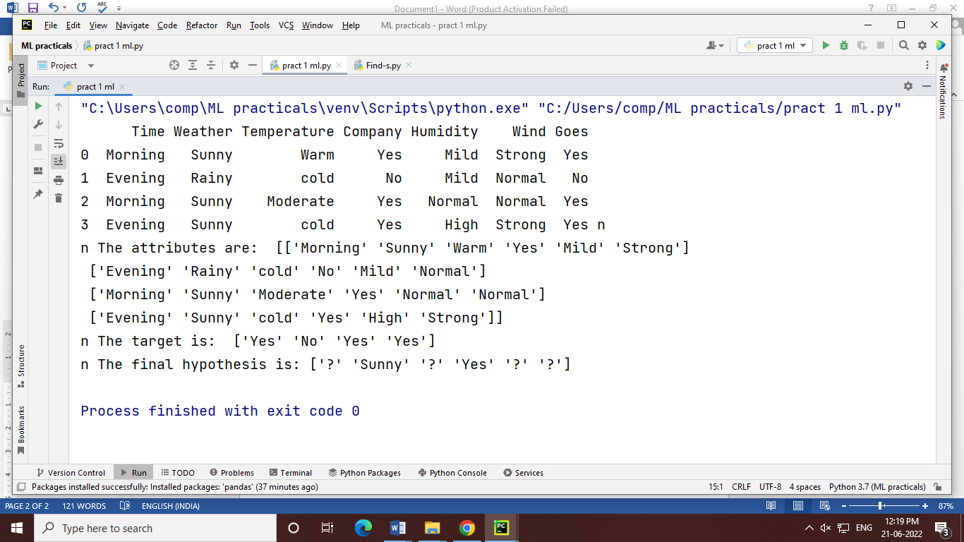

# Program of Decision
import matplotlib.pyplot as plt
#from sklearn.datasets import load_iris
from sklearn.datasets import load_breast_cancer
#from sklearn.datasets import fetch_california_housing
from sklearn.tree import DecisionTreeClassifier
from sklearn import metrics
#Import scikit.learn metrics module for accuracy calculation
#from sklearn.ensemble import RandomForestClassifier
from sklearn.model_selection import train_test_split
import pandas as pd
import numpy as np
from sklearn import tree
data_b = load_breast_cancer()
print(data_iris)
#housing = fetch_california_housing()
#housing
#boston=load_boston()
df=pd.DataFrame(data_b.data,columns=data_b.feature_names)
df['target'] = data_b.target
#df['target']
print(df)
X_train, X_test, Y_train, y_test = train_test_split(df[data_b.feature_names], df['target'], random_state=1)
print(X_train)
print(X_test)
# Step 1: Import the model you want to use
# This was already imported earlier in the notebook so commenting out
#from sklearn.tree import DecisionTreeClassifier
# Step 2: Make an instance of the Model
#max_depth = 4
clf = DecisionTreeClassifier(max_depth = 3,random_state = 0, criterion='gini') #'gini'
# Step 3: Train the model on the data
clf.fit(X_train, Y_train)
# Step 4: Predict labels of unseen (test) data
# Not doing this step in the tutorial
#clf.predict(X_test)
tree.plot_tree(clf);
y_pred = clf.predict(X_test)
print("Accuracy:",metrics.accuracy_score(y_test, y_pred))

#Program for simple regression
import numpy as np
import matplotlib.pyplot as plt

def estimate_coef(x, y):
# number of observations/points
n = np.size(x)

# mean of x and y vector
m_x = np.mean(x)
m_y = np.mean(y)

# calculating cross-deviation and deviation about x
SS_xy = np.sum(y*x) - n*m_y*m_x
SS_xx = np.sum(x*x) - n*m_x*m_x

# calculating regression coefficients
b_1 = SS_xy / SS_xx
b_0 = m_y - b_1*m_x

return (b_0, b_1)

def plot_regression_line(x, y, b):
# plotting the actual points as scatter plot
plt.scatter(x, y, color = "m",
marker = "o", s = 30)

# predicted response vector
y_pred = b[0] + b[1]*x

# plotting the regression line
plt.plot(x, y_pred, color = "g")

# putting labels
plt.xlabel('x')
plt.ylabel('y')

# function to show plot
plt.show()

def main():
# observations / data
x = np.array([0, 1, 2, 3, 4, 5, 6, 7, 8, 9])
y = np.array([1, 3, 2, 5, 7, 8, 8, 9, 10, 12])

# estimating coefficients
b = estimate_coef(x, y)
print("Estimated coefficients:\nb_0 = {} \
\nb_1 = {}".format(b[0], b[1]))

# plotting regression line
plot_regression_line(x, y, b)

if __name__ == "__main__":
main()
#Program for KNN classification
import pandas as pd
data = pd.read_csv("/content/Iris.csv")
print(data.head())
x = data.iloc[:,1:5].values
y = data.iloc[:,5].values
data['Species'].value_counts()
## Split the data into training and testing
from sklearn.model_selection import train_test_split
xtrain,xtest,ytrain,ytest = train_test_split(x,y,train_size=0.80,random_state=3)
import numpy as np
np.unique(ytrain,return_counts=True)
## Build the model
from sklearn.neighbors import KNeighborsClassifier
model = KNeighborsClassifier(n_neighbors=3)
#### Train the model
model.fit(xtrain,ytrain)
ypred = model.predict(xtest)
print(ypred)
print(ytest)
from sklearn.metrics import confusion_matrix
cm = confusion_matrix(ytest,ypred)
print(cm);
### Accuracy Score
from sklearn.metrics import accuracy_score
acc = accuracy_score(ytest,ypred)
print(acc)
accuracy = []
for i in range(1,100):
model_1 = KNeighborsClassifier(n_neighbors=i)
model_1.fit(xtrain,ytrain)
ypred_1 = model_1.predict(xtest)
acc_1 = accuracy_score(ytest,ypred_1)
accuracy.append(acc_1)
print(accuracy)
model.predict([[2.3,4.5,2.3,5.6]])

def flower():
sl = float(input("Enter sepel length:"))
sw = float(input("Enter sepel width:"))
pl = float(input("Enter petel length:"))
pw = float(input("Enter petel width:"))
fl = model.predict([[sl,sw,pl,pw]])
print("The expected type of flowers "+str((fl[0])))

flower()

##Program 7 :Write a program to implement the naïve ##Baysian Classifier

import numpy as np
import matplotlib.pyplot as plt
import pandas as pd

from sklearn.datasets import load_iris
data_i = load_iris()
df=pd.DataFrame(data_i.data,columns=data_i.feature_names)
df['target'] = data_i.target
print(df)

from sklearn.model_selection import train_test_split
X=df[data_i.feature_names]
y=df['target']
X_train, X_test, y_train, y_test = train_test_split(X, y, test_size = 0.2)

from sklearn.preprocessing import StandardScaler
sc = StandardScaler()
X_train = sc.fit_transform(X_train)
X_test = sc.transform(X_test)

## naive bayes claassifier using Gaussian Function
from sklearn.naive_bayes import GaussianNB
classifier = GaussianNB()
classifier.fit(X_train, y_train)

y_pred = classifier.predict(X_test)
y_pred

from sklearn.metrics import confusion_matrix
cm = confusion_matrix(y_test, y_pred)
from sklearn.metrics import accuracy_score
print ("Accuracy : ", accuracy_score(y_test, y_pred))
print(cm)

df = pd.DataFrame({'Real Values':y_test, 'Predicted Values':y_pred})
print(df)

